PROSEDUR KENDALI DOKUMEN | LSG-05.03
SURAT PERMINTAAN BARANG | HO/SH | THN

Nama Kapal : KM. SABUK NUSANTARA 47
Tanggal : -
Bagian : Mesin

NO. | NAMA BARANG | QTY | KETERANGAN | SUPPLY | FOTO
1 | Piston  Harbour Generator  Merk : Deutz  Model : F3L912 | 1 Unit | Baret (No 2) |  | 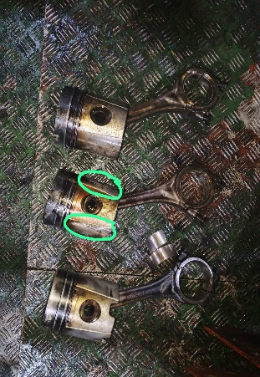
2 | Ring Piston  Harbour Generator  Merk : Deutz  Model : F3L912 | 3 Set | Sudah Aus/Kompresi Los |  | 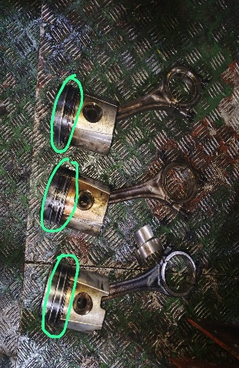
3 | Metal Jalan/Conrod Bearing  Harbour Generator  Merk : Deutz  Model : F3L912 | 3 Set | Patah/Sudah Aus |  | 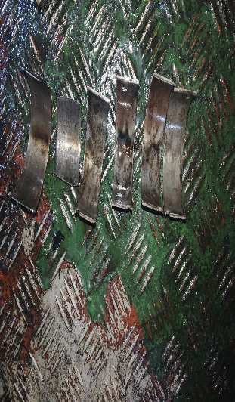
4 | Gasket Manifold  Harbour Generator  Merk : Deutz  Model : F3L912 | 6 Pcs | Hancur |  | 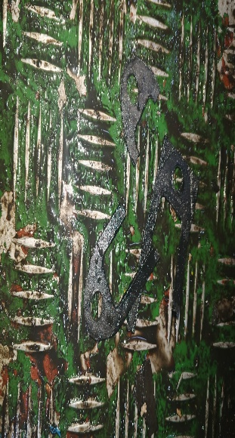
5 | Push Rod  Harbour Generator  Merk : Deutz  Model : F3L912 | 1 Pcs | Bengkok |  | 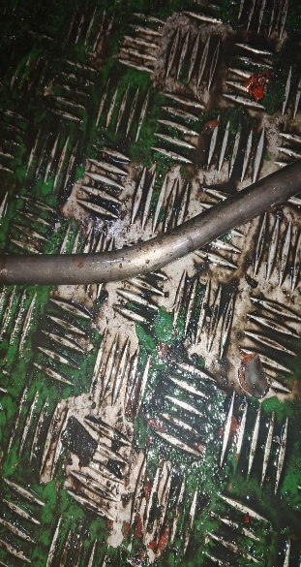
6 | Seal Pipa Pushrod  Harbour Generator  Merk : Deutz  Model : F3L912 | 12 Pcs | Rusak/Hancur |  | 
7 | Cover Seal Pipa  Harbour Generator  Merk : Deutz  Model : F3L912 Pushrod | 2 Pcs | Rusak |  | 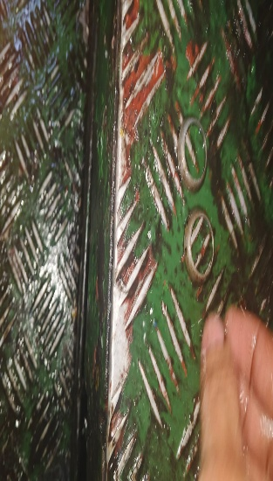
8
9
10

Mengetahui, Mengetahui, Menyetujui,

_________ _ ___________ ___________
PORT CAPT/ ENGINE LOGISTIK Manager Armada

